**Allison Mack in Trouble with the Law**



On April 20, 2018, a 35 year old woman, jotted in the detective’s notebook simply as AM was arrested by the FBI on charges of sex trafficking, sex trafficking conspiracy and forcedlabor conspiracy. But this was no ordinary woman. This was Allison Mack, an award winning actress best known for her starring role as Chloe Sullivan in the *Smallville* television series and for playing the character Amanda on the *Wilfred* television series. This was someone who was a child celebrity in advertisements for 'German Chocolate' at the age of 4.

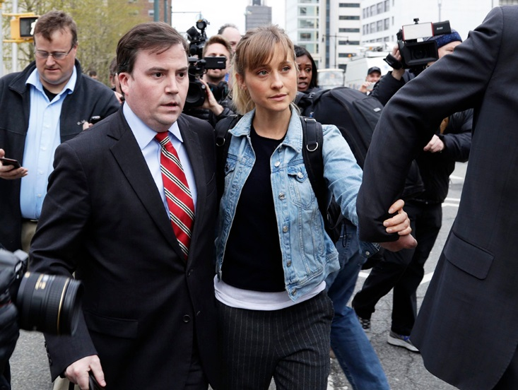

Allison has appeared in court together with another accused, Keith Raniere who has been named as the founder of NXIVM, an organization fronting as a women’s self-help group but in actuality was a sex cult. The organization is suspected of propagating “a cult-like program aimed at breaking down subjects psychologically".

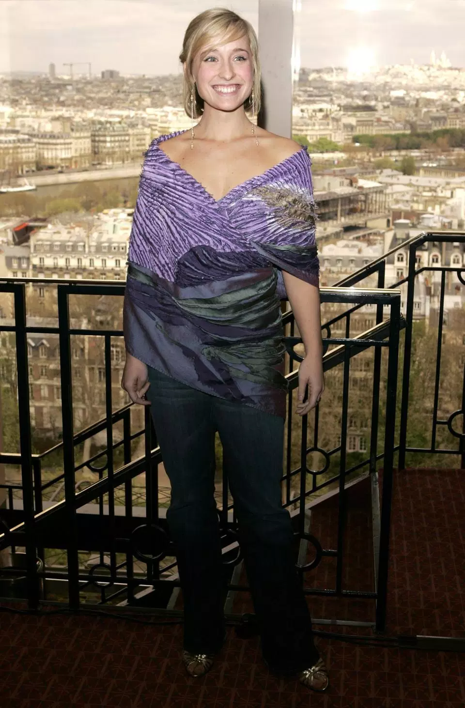

Allison is accused of being the second in command in the organization. Government prosecutors allege that she used high handed antics such as blackmail to coerce women into engaging in sexual activity with Raniere against their wishes and thereafter enslaving them to do menial jobs, for which she received monetary compensation from Raniere. She was released four days after the arrest on a $5 million bond but placed on house arrest in her parent’s house in California. Her co-defendant, Raniiere, is being held in prison without bail. Investigators have revealed shocking details of human trafficking and abuse going on in the cult.



Consequently, U.S. attorneys filed explosive documents in federal court. The documents “identify alleged victims of human smuggling, alien harboring, physical or mental abuse towards an intimate partner and stalking.” The attorneys also claim they have evidence of sex-related crimes such as “sexual abuse or sex trafficking.”

Apparently, the government is not taking this case lightly for a warning has been issued to both defendants that the government has highly damaging evidence that requires the documents to be redacted. The government statement reads as follows: “Some victim discovery material is composed of highly sensitive information including but not limited to medical information, discussion of mental and physical conditions, photographs and videos of victims, letters and videos that alleged victims provided as ‘collateral,’ sexual history and sexual conversations.”



The case, surely will affect her career; a career that had hitherto been illustrious. Allison made her television debut in a role as a self-harming teenager *7th Heaven* in 1998. Thereafter she appeared in several television series including *Opposite Sex* in 2000 and *The Nightmare Room*. She also played key roles in films such as *My Horrible Year, Police Academy 6* and *City Under Siege.*

The American nation is shocked to see that a young lady that has won the hearts of so many may be facing a jail sentence. Whatever will become of the several awards and nominations she won in her role in the Smallville series and the Teen Choice Award for Best Sidekick in 2006 and 2007, they are asking. All eyes will be in the courtroom when she next appears in court.